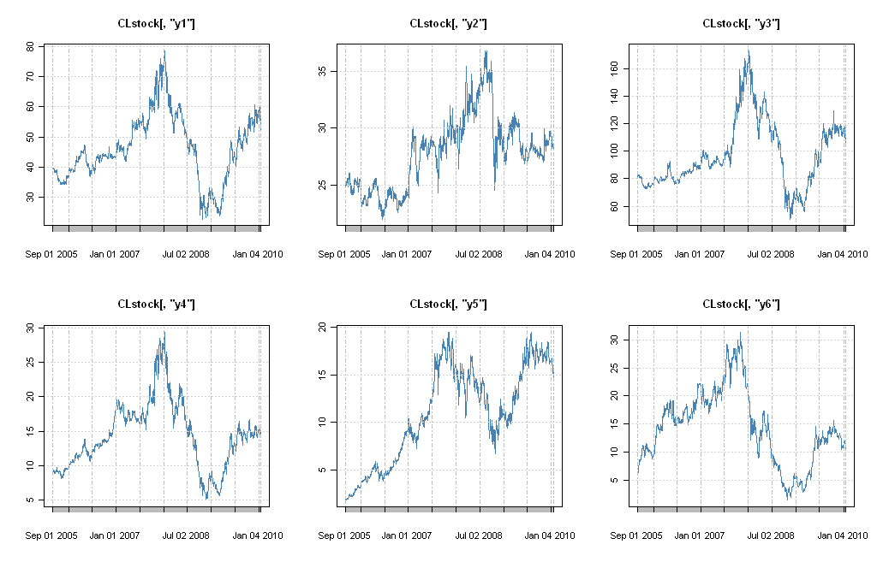

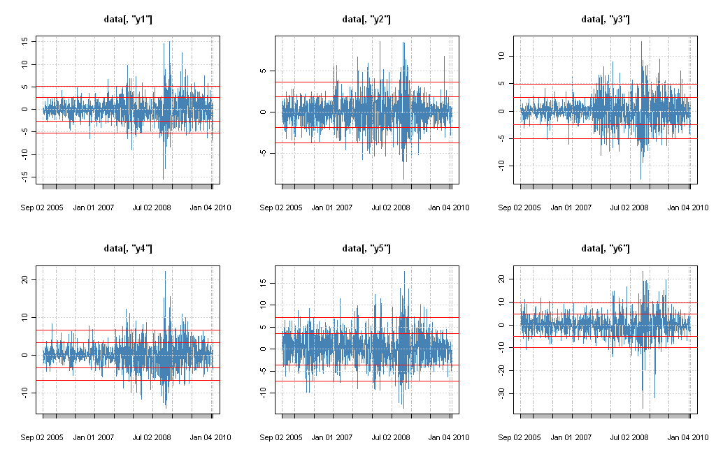

Iteration=50

ro<-c(0.2,0.8)

Pi

[,1] [,2]

[1,] 0.6 0.7

[2,] 0.4 0.3

Gamma1

[,1] [,2] [,3] [,4] [,5] [,6]

[1,] 1.0000000 0.2758412 0.7531578 0.6795768 0.4765810 0.4061608

[2,] 0.2758412 1.0000000 0.3325303 0.2725871 0.2187979 0.1690054

[3,] 0.7531578 0.3325303 1.0000000 0.6996598 0.5069226 0.4040805

[4,] 0.6795768 0.2725871 0.6996598 1.0000000 0.5151846 0.4103381

[5,] 0.4765810 0.2187979 0.5069226 0.5151846 1.0000000 0.5178337

[6,] 0.4061608 0.1690054 0.4040805 0.4103381 0.5178337 1.0000000

Gamma2

[,1] [,2] [,3] [,4] [,5] [,6]

[1,] 1.0000000 0.3034254 0.8284735 0.7475345 0.5242391 0.4467769

[2,] 0.3034254 1.0000000 0.3657834 0.2998458 0.2406777 0.1859059

[3,] 0.8284735 0.3657834 1.0000000 0.7696258 0.5576149 0.4444885

[4,] 0.7475345 0.2998458 0.7696258 1.0000000 0.5667030 0.4513719

[5,] 0.5242391 0.2406777 0.5576149 0.5667030 1.0000000 0.5696171

[6,] 0.4467769 0.1859059 0.4444885 0.4513719 0.5696171 1.0000000

Ro [1] 3.040191e-26 [2] 1.000000e+00

Pi [,1] [,2]

[1,] 0.476398 0.1828603

[2,] 0.523602 0.8171397

Gamma1

[,1] [,2] [,3] [,4] [,5] [,6]

[1,] 1.0000000 0.2082711 0.5733323 0.6818212 0.4402760 0.3028847

[2,] 0.2082711 1.0000000 0.3243826 0.3180878 0.1313209 0.1946090

[3,] 0.5733323 0.3243826 1.0000000 0.6914477 0.4534209 0.2695172

[4,] 0.6818212 0.3180878 0.6914477 1.0000000 0.7071200 0.4495866

[5,] 0.4402760 0.1313209 0.4534209 0.7071200 1.0000000 0.3802384

[6,] 0.3028847 0.1946090 0.2695172 0.4495866 0.3802384 1.0000000

Gamma2

[,1] [,2] [,3] [,4] [,5] [,6]

[1,] 1.0000000 0.3028700 0.8393170 0.6925891 0.5055369 0.4548408

[2,] 0.3028700 1.0000000 0.3407221 0.2608350 0.2571584 0.1534728

[3,] 0.8393170 0.3407221 1.0000000 0.7133920 0.5311007 0.4565843

[4,] 0.6925891 0.2608350 0.7133920 1.0000000 0.4562883 0.4041963

[5,] 0.5055369 0.2571584 0.5311007 0.4562883 1.0000000 0.5767160

[6,] 0.4548408 0.1534728 0.4565843 0.4041963 0.5767160 1.0000000

